**Team Meeting**

**02 NOVEMBER 2021**

**Agenda**

## **Last Meeting Follow-up**

1. Update for max78000 terminal output

## **Eclipse and Terminal Issues**

1. Was able to get kws20_demo working on multiple boards

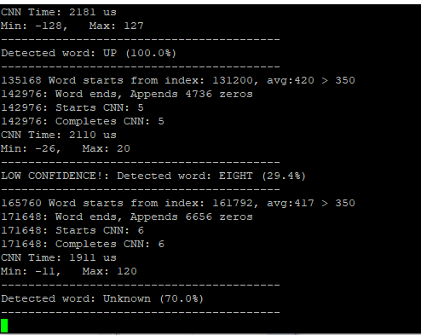

1. Error when attempting to run snake_game_demo

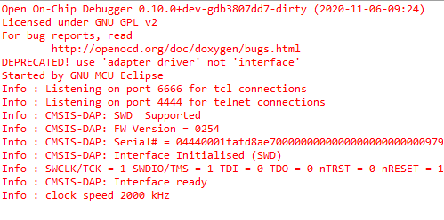

4. Successfully unlocked a MAX78000 since it was no longer programmable

## **Quantization-Aware Training**

1. Non Quantization-Aware Trained model requires BatchNorm Fusing
2. One model was created using QAT (Quantization-Aware Training)

## **Model Evaluation**

1. Trained two nearly identical models
2. One is trained with QAT and other is not
3. Goal is to evaluate the performance effect of QAT

## **Network Loader (ai8ize)**

1. YAML file created: description of the file used to create the C code
2. Purpose of the YAML network description is to describe the structure and manage processors

**Question**

1. For the network loader we require a sample input, for the sample input we are able to use either randomly generated images or images from our training data but we do not know the impact of either option, do you have any advice on what we should use for the sample input?

# **Next Meeting Agenda**